**LAB 3.1** A survey has been conducted by an organisation which consider the following items. Create a survey form, as shown in the following figure. Display the input made by the user.

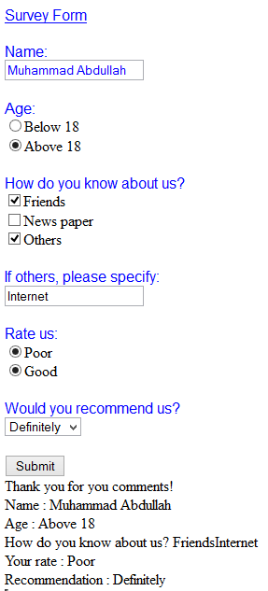

**LAB 3.2** Create a form as shown below. Add a list of items for your DropDownList. The list of items in your DropDownList can be anything you like - pop groups, football teams, favourite foods, anything of your choice. Then try the following:

Use a select case statement to test what a user has chosen from your DropDownList. Give the user a suitable message when the button was clicked.

